Final design Document

Jack Anstey

**Functional Overview:**

This is a statistical analysis tool to visually see what type of music that you enjoy. Users may already know what they like, but not know stats such as:

* Most played song
* Genre that is most prevalent in saved and playlists
* A dynamic pie chart that shows all genres that make up your saved music and playlists

By using the Spotify api, I will be able to show all of this data and more to the user while also being able to serve them recommendations for other songs for them to listen too

**Design Overview:**

This will be an informative statistical analysis tool for user to visually see their music in Spotify. I will be using the Spotify API to gain access to user credentials and gain a token. It will then show a pie chart of the percentages/raw numbers of the genres that they listen to. It will show a bar chart of their 5 most listened too songs and a separate bar chart of their top 5 most listened to artists as they highlight different sections of the pie chart. At the bottom of the page will be recommendations of future songs that they should listen to and share buttons to promote the website on facebook, Instagram, reddit, etc.

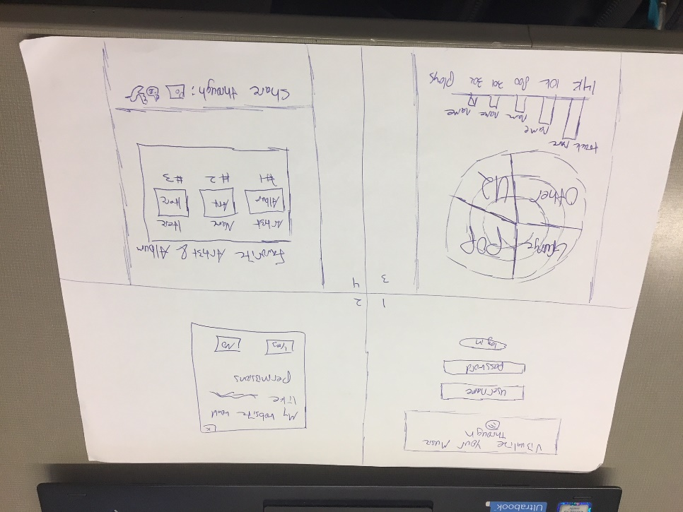

**Design Testing Results:**

Myself for initial testing

My father. Feedback: put all the main information upfront. People don’t really like to scroll. Make it so when I highlight the pie chart more information comes up in a given section (i.e highlight pop and get more information about your pop stats)

Luke F: Use Spotify colors and CSS and a user suggestion form at the bottom of the page (this can be placed into a database)

**Prioritization of Features:**

Excellent and cohesive CSS that makes my website look legitimate

Securely store passwords, create real unique user ids, and store tokens

Getting the Raw values for my stats

Making the stats visually appealing and dynamic (change while scrolling down the webpage)

Making the pie chart able to handle the functionality of highlighting

**Database design:**

Unique user id (this will not be sequential with the number one)

Will contain the access token for the current sessions

Store the user name and a hashed+salted password

**Proposed Implementation Schedule:**

Week one: make basic framework of website and learn tokens and the basics of getting data from Spotify and be able to place the token in the SQL Data base

Week two: make sure tokens are working properly

If needed (not sure if I need too with the Spotify api) passwords are hashed and salted

All the data that I want from a given user is easily able to be collected and can scale depending on the amount of music someone has. This will be placed in the user’s row in the SQL database.

Begin Javascript pie chart process here. I want this to be done by my birthday (11/8)

Week three: visual process begins. Begin writing CSS in conjunction with Javascript to create the pie chart.

Week four: bug fixes and continued work on CSS and Javascript. This will for sure happen on 11/17 which is testing day

Project due at 11/22 @ 5pm

**Potential Showstoppers and Open Questions:**

How will returning users be handled. How often do tokens refresh and how do I request a new one from Spotify? Will learning Javascript to make visually appealing graphs be too much for me/making them interactive in a user-friendly way